ABC Brainstorming Organizer
Topic: Maine Winter
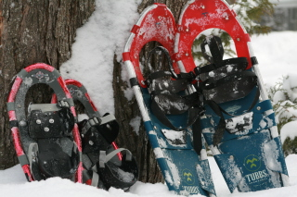

A _________________________ N___________________________
B _________________________ O___________________________
C _________________________ P ___________________________
D _________________________ Q ___________________________
E _________________________ R ___________________________
F _________________________ S____________________________
G _________________________ T ____________________________
H _________________________ U ___________________________
I __________________________ V ____________________________
J __________________________ W ___________________________
K__________________________ X____________________________
L __________________________ Y ___________________________
M __________________________ Z ____________________________

